**Report**

**Maunil Vyas :- 1401025**

**Deep Patel :- 1401010**

**Shreyas Patel :- 1401025**

**Project Duration :- Monsoon 2015**

**Instructor :- Prof.Ashok Ranade**

**Goal**

To build a Synthesizer software that is capable of generating and playing 22 different notes.

**Motivation**

The usual electronic synthesizer uses 12 notes in an octave. However, Indian classical musicians use 22 *‘Shrutis’* (Notes) in an octave. But the Instruments with 22 notes are rarely available. In order to solve this problem we started this project.

**Platform**

Scilab 5.5.2

**Reason for selecting this platform**

1). Open Source

2). Efficient matrix based calculations which was suitable for notes generation.

**Features**

1). Generate 22 different frequency notes.

2). Emulates lots of different instrument.

3). Easy user Interface.

4). User can make changes in the program.

**What we Did?**

**First attempt:-**

**Process:-**

We generated different notes with sine and cosine functions and ADSR(Attack Decay Sustain Release) envelopes, by changing phase and frequencies of the sinusoids.

**Result:-**

We successfully generated and played all the 22 notes and also we built a simple user interface. But due to wave problem there was a ‘click’ sound after end of each note.

**Second attempt:-**

**Process:-**

Here we changed our approach to note generation. Instead of generating artificial frequencies we first recorded a sample frequency (Sample Note) from lots of music instruments and then we sampled them to generate different frequencies (Notes) using interpolation and decimation.

**Result:-**

We successfully generate and played all the 22 notes. We were also able to remove 99.99% of click sound from notes, because recorded notes already have their own envelopes with particular time duration so it will not cause click sound.

**Contents from Project:-**

**Generated Frequency Chart:-**

C:\Users\User\AppData\Local\Microsoft\Windows\INetCache\Content.Word\1.png

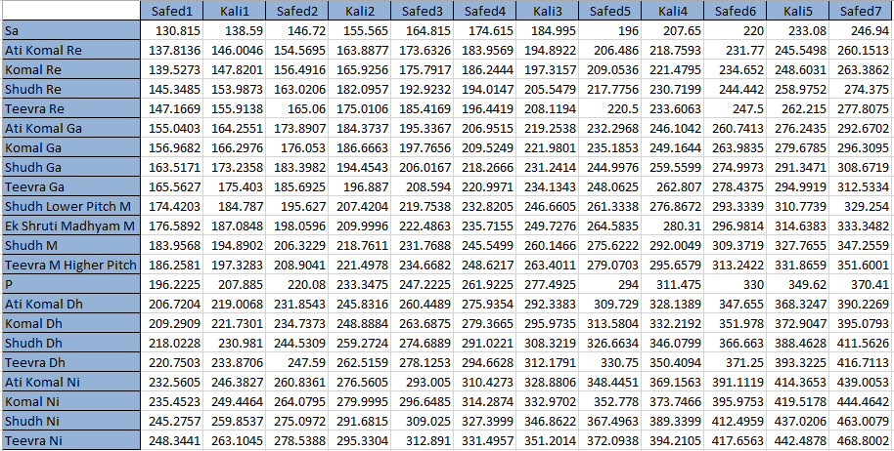

maddhya

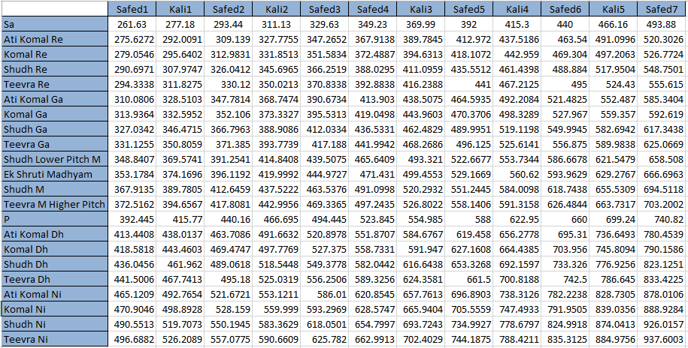

2

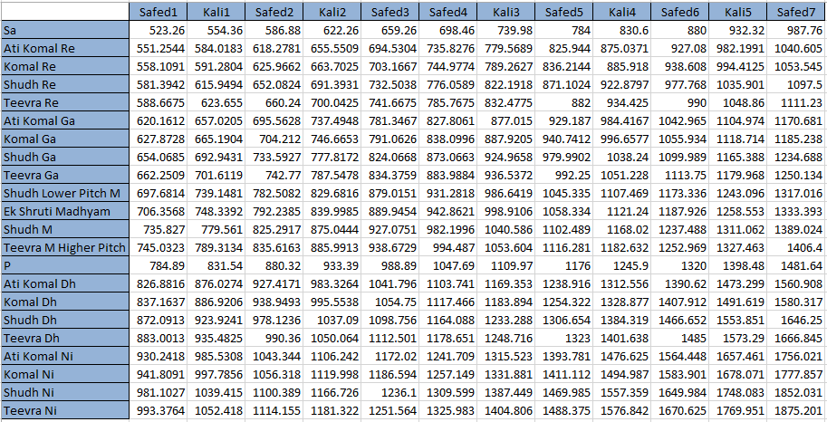

In the above table Blue Columns and row has the names of notes and ‘Sadaj’ respectively and white portion is the frequencies.

**Different instruments that can be played in our Synthesizer:-**

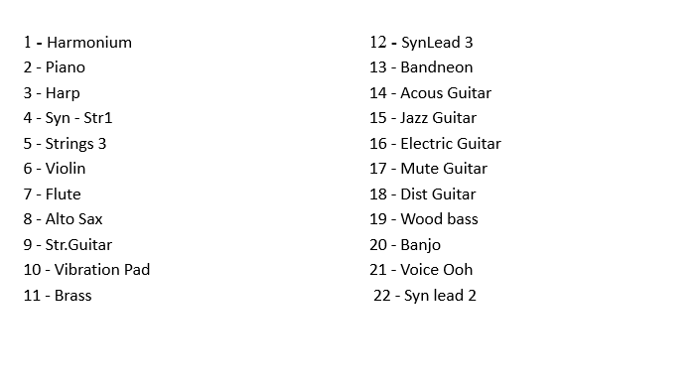

**Keyboard-‘Soor’ Mapping:-**

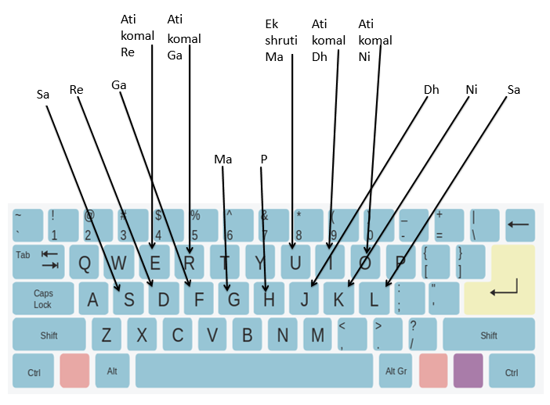

**Problems faced**

During project we faced two major problems:-

1). Due to Scilab limitations, when user press and hold a particular key, the corresponding note keeps playing repeatedly, and spoils the music. But this problem was solved.

2). When each note was played, it ended with *‘katt’* sound and also spoiled music, but this problem was also solved.

**Current state and future goal**

We have successfully generated twenty two notes using Scilab platform. Our future goal is to Design and develop embedded based standalone 22 *Shruti* (Notes) Synthesizer.

**References:-**

**Websites:-**

<http://www.synthschool.com/free-plug-ins/index.html>

<https://play.google.com/store/apps/details?id=com.symbolic.pitchlab&hl=en>

<http://www.22shruti.com/>

<www.wikipedia.org>

**Documentation:-**

Scilab Documentation